MicroGoal
Ideation Phase
Define the Problem Statements

Date | 7-03-2026
Team ID | SWTID-2026-3793
Project Name | MicroGoal
Maximum Marks | 2 Marks
Problem statement
Many individuals face challenges in organizing and tracking their short-term and long-term goals due to the limitations of current systems. Most platforms are either overly complex, lack proper security measures, or fail to offer reliable authentication and data protection. There’s a clear need for a streamlined and secure backend solution that allows users to effortlessly create, update, and access their goals with confidence and privacy.
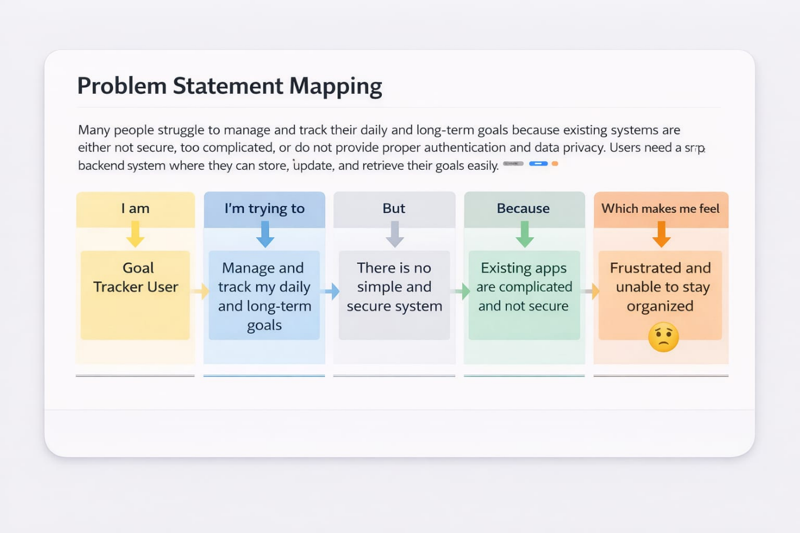

🧩 MicroGoal Backend Planning – User-Centric Table
Audience | What They Need | Common Struggles | How MicroGoal Helps
Student | A straightforward tool to manage academic and personal goals | Overwhelmed by cluttered apps and lack of structure | Offers a clean backend with secure login and intuitive goal tracking
Working Professional | A reliable system to monitor career progress and team objectives | Concerned about privacy and poor data handling | Provides encrypted storage and authenticated access for professional goal management
Beginner Developer | Practical exposure to backend systems and documentation workflows | Confused by middleware, JWT, and testing setups | Supplies real-world templates and examples for backend learning
General User | A simple way to define, update, and view personal goals | Frustrated by apps that crash or lose data | Delivers a stable backend with smooth goal retrieval and update features

